WBIF - Support to Water Resources Management in the Drina River Basin

The Ministry of Foreign Trade and Economic Relations of Bosnia and Herzegovina applied for the WBIF (Western Balkans Investment Framework) fund to support the regional project of management of water resources in the Drina River Basin. The Project started with implementation on October 14, 2014, and is being implemented by the International Bank for Reconstruction and Development (World Bank).
The implementation of the Project involves the competent institutions of the three countries of the Danube river basin (Serbia, Bosnia and Herzegovina and Montenegro).
The objective of the Project is to support more effective water resources management in the Drina river basin with a special focus on flood and drought mitigation, and hydropower and environmental management within the framework of integrated water resource management (IWRM).
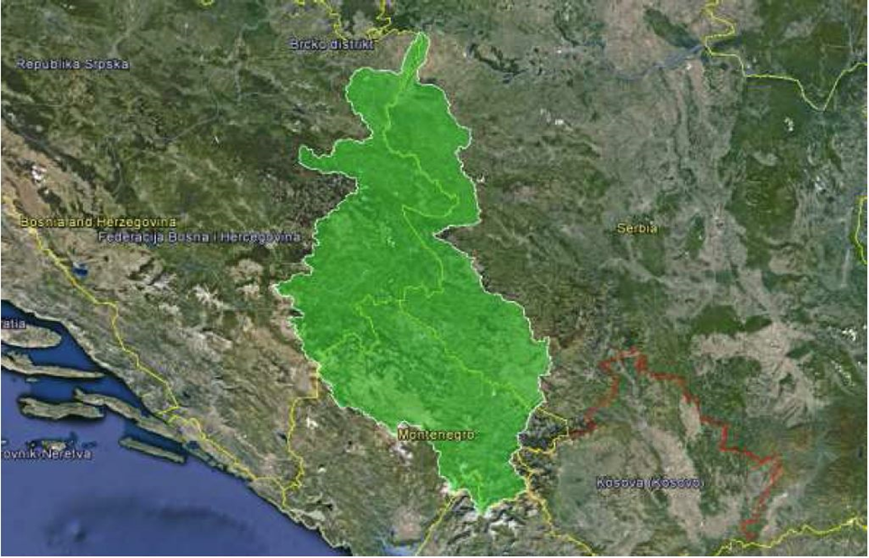
*Drina River Basin (downloaded from the Project website: http://www.wb-drinaproject.com/index.php/en/)
Within the framework of the Project implementation a series of documents has been developed contributing to the strengthening of regional cooperation and better management of water resources in the Drina river basin, in line with IWRM principles, as well as domestic and EU legislation.
One of the results of the Project was the Report on Integrated Water Resources Management (IWRM) in the Drina River Basin, for each country separately. This report is the starting point for the preparation of the Investment Prioritisation Framework for BiH and the drafting of the Drina River Basin Roof Report for all three basin countries.

Public Consultations on the Investment Prioritisation Framework for BiH were held on 5 July 2017. The finalization of this document is underway as well as the Drina River Basin Roof Report.
At the workshop held in Belgrade on 5 December, the Project's final results were presented. The workshop was attended by the representatives of relevant institutions from all three countries of the Drina river basin.
The end of the project is expected on 31 December 2017.
All documents are available on the website:
http://www.wb-drinaproject.com/index.php/sr/dokumenti

